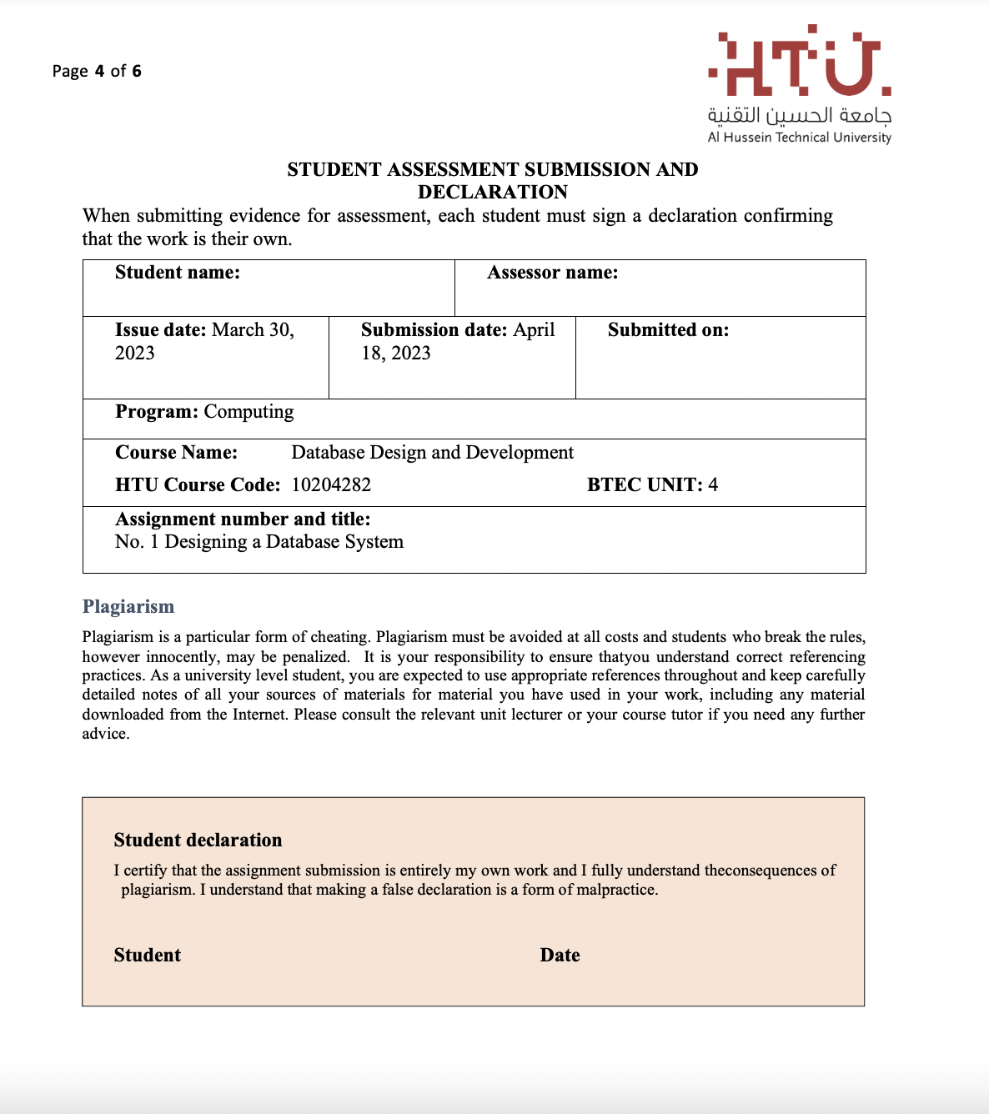

18-4-2023

Saif haddad

D.Salem emashat

18-4-2023

Saif kamal haddad